TEAM E-JUNKY

**PROBLEM STATEMENT-**

“Recycling is not just for paper and pop can; technology can be recycled too.”

With advancement in technology, the amount of e-waste being generated is ever increasing. India stands fifth in the list of countries producing the maximum amount of e-waste or electronic waste. Unfortunately, the disposal system in India is not as efficiently working as it should have been for a country that produces 2 million tons of e-waste annually. The root cause of this maybe the lack of awareness among people. Even the educated lot doesn’t understand the need of proper disposal of e-waste. They tend to toss it in the trash can instead of sending it for proper disposal and recycling. They either get rid of it along with the daily domestic waste or sell it to a local ‘kabadiwala’. They are the scrap dealers who take all the electronic waste and dump it an illegal dump yard. At some of these dump yards, the e-waste is not recycled but is thrown into acid ponds. This practice has led to many health and environmental hazards. People living near these areas are prone to cancer and the land there is unfit for agricultural practices. In other cases, the waste is handled on open grounds and broken down manually to extract recyclable metals to be resold, leaving both the workers and soil exposed to toxic materials like lead, cadmium, mercury and the acid fumes generated in the process. According to experts, prolonged exposure to these can cause nausea, irritability, head ache and liver and kidney problems the long run. Child labours are a common sight at the illegal extraction sites. A report released by Assocam-Frost and Sullivan on the World Earth day pointed out that 5 lakh children between the ages of 10 and 14 were engaged in these activities jeopardizing their lives.

**SOLUTION-**

We’ve come up with e-junky to help make this system more organized. E-junky is a platform where exchange and transportation of e-waste to authorized dumping stations takes place. According to the government norms, institutions and corporates need to send their e-waste to a government licensed dumping station.

This application will be of use for domestic households, legal dumping stations and corporate offices/institutions. In addition to that, we’ll also be employing junk dealers or kabadiwalas who, in today's scenario have a very meagre income.

In addition to this we have introduced a Vending machine which take electronic materials (called e-waste) as a waste and which can be batteries, charger, USB wires, mobile phones, etc. and in exchange of these waste the user will have a choice to go for the deal they feel is the best.

**This can be considered as a fourth bin after the three bins available in public place.**

For corporates, we’ve developed an application where they will upload a picture and the details of the e-waste that they want to get rid of. They will be provided some estimated cost of the waste, if the user gets agree he/she can accept the approval. This input from them will be visible to concerned authorities. The dumping stations will then bid over the waste. The pickers will be sent to the pick-up location from where they are supposed to collect the e-waste with a vehicle as per the requirement and will ship it to the concerned dumping station. The app will show the users the location of the pickers and they will be able to review and rate the person who had provided them the service.

For domestic households, the users will upload a picture of the material they see as e-waste and our picker will pick it up from their homes. This e-waste will be our possession until we have a collection of e-waste of a certain amount of quantity. Then, we’ll put the material forth for bidding and we’ll sell it to the dump house that gives us the best price. Every time the users will use E-junky, they will earn credits that they can redeem or use for online shopping or in some outlets. These credits will be stored in an e-wallet.

***E-junky is India’s first application and website that makes sure that e-waste reaches the right place where it will be recycled properly.***

**INNOVATION-**

It will be safe to say that e-junky is a one-of-a-kind concept which is designed such that the users get to dispose their e- waste through a proper procedure. E-junky keeps illegal dumping stations from getting their hands on the e-waste. At the same time, it employs the pickers and gives them a proper job. It also reduces the chances of intoxicating the environment and thus saves people from various life-threatening diseases.

We have used artificial intelligence, machine learning and IOT for data analytics. These elements have enabled us in making proper and precise data sets as shown in Fig1.1.

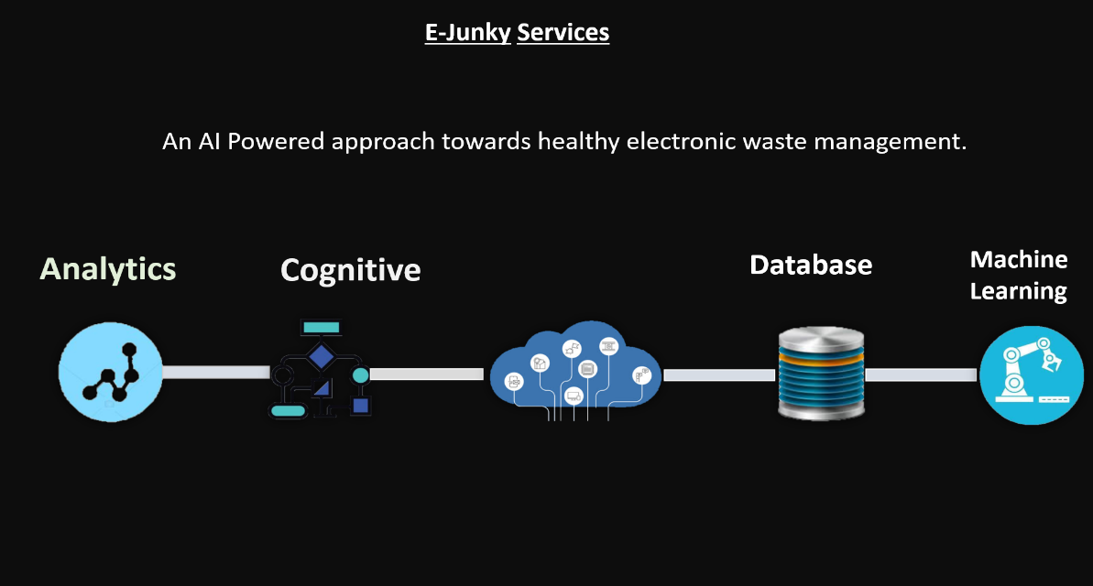

**Fig 1.1**

These data sets may turn out to be of immense importance for the government as they will give them vital information about the generation and disposal of e-waste. E-junky will give the users a large number of options to choose from while selling their e-waste while keeping the all the illegal elements out of the loop and allows a proper functioning of the system. All in all, e-junky promotes legal and ethical ways of e-waste disposal as well as well-being of the people involved.

Referring to fig 1.2, data is sent by the user through touch screen for e-waste prediction. Push notifications will be sent to picking agency and optimized pickup plan will be scheduled for delivering the vending machines’ e-waste to authorized dump yard.

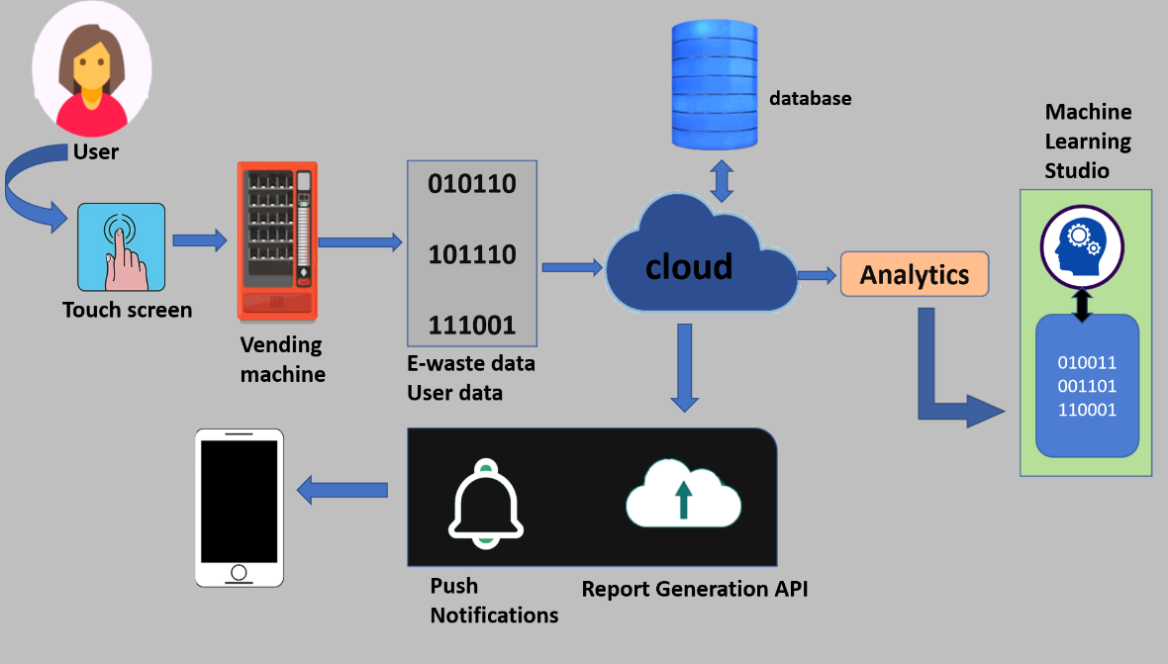

**Fig 1.2**

**E-junky can be a best solution for better future. A balance of technology, usage and disposal and to remove the illegal chain of the pickers is the primary goal of E-junky It helps you to work in an organized environment.**

**TECH STACK-**

1. AI
2. ML
3. IOT
4. RPi
5. Azure cloud computing

**UNIQUE FEATURES-**

1. E-junky is a one-of-a-kind concept that is designed such that the users get to dispose of their e-waste through a proper procedure.
2. E-junky keeps illegal dumping stations from getting their hands on the e-waste.
3. At the same time, it employs the pickers and gives them a proper job.
4. It also reduces the chances of intoxicating the environment and thus saves people from various life-threatening diseases.
5. We have used artificial intelligence, machine learning, and IOT for data analytics. These elements have enabled us in making proper and precise data sets.
6. These data sets may turn out to be of immense importance for the government as they will give them vital information about the generation and disposal of e-waste.
7. E-junky will give the users a large number of options to choose from while selling their e-waste while keeping all the illegal elements out of the loop and allows proper functioning of the system.

**All in all, e-junky promotes legal and ethical ways of e-waste disposal as well as well-being of the people involved.**